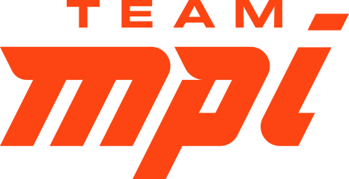

Team MPI 2020 Coaches Retreat – East Coast
January 11, 2020
COURTYARD ST. PETERSBURG CLEARWATER
3131 Executive Drive, Clearwater, Florida 33762

FRIDAY
12-4:00 Arrival of Coaches
5:00-7:00 Team MPI Coaches and their Guests Reception, Location: TBD
7:30 Dinner (YOYO) (You’re on Your Own)
SATURDAY Open to ALL Coaches and Athletes
6:30–7:30am Breakfast: YOYO
7:15–7:30 Check-in for visiting Coaches (outside of Team MPI)
7:30 Welcome Remarks - Mark Sortino
7:30–8:30 "Growing Your Coaching Business" - Mark Sortino
8:45–9:45 "Athlete Retention - A Coach & Athlete Perspective" - Laura Henry
9:45–10:15 Group Discussion Block
10:15–11:15 "IRONMAN® University: The Path Ahead" - Earl Walton (Director of IMU)
11:15–12:15 Lunch (YOYO)
12:15–1:15 “Bike Fitting for Everyone, Practical Application” - Adam Sczech
1:30–2:30 “Coaching NEW Adult Swimmers, Best Practices" – Mark Sortino
2:30-3:00 Group Discussion Block
3:00–4:00 "Coaching the Para-Athlete" - Becky Piper
4:00–5:00 "Including Mental Strength Training in your Athlete's Plan" - Mark Turner
5:00 Wrap up for the day - Mark Sortino
6:30 Dinner (YOYO)

SUNDAY Team MPI Coaches ONLY
6:30–7:30am Breakfast: YOYO
7:30–8:30 "Harnessing Social Media the RIGHT Way" - Cortney Martin
8:45–9:45 “Creating Endurance Efficiency" – Dr. Manuel Delgado Gaona
9:45–10:15 Group Discussion Block
10:15-11:00 “Partnering with Local Businesses - A How To" - Maria Netherland
11:15-12:00. “Coaching Three Athletes to IRONMAN® Success" - Gregg Edelstein
12:00 Wrap up and Retreat concludes - Mark Sortino

Bio’s on ALL Presenters (except IRONMAN®) can be found at: https://www.teammpi.com/our-team

